TOOLKIT: July 28, 2021 – Rental Assistance Call to Action
Purpose: The purpose of this toolkit is to provide stakeholders with information about how to raise awareness about the rental assistance resources available to tenants and landlords.
Toolkit Table of Contents: The toolkit includes the following resources for partners:
- Background on the call to action
- Information on the CFPB rental assistance look up tool
- Sample messages and materials: Social media, email, web text, fliers, press release, graphics

Important Resources for Social Media Amplification:
- Link to CFPB Look Up Tool: consumerfinance.gov/renthelp
- Hashtag: #RentHelp

NOTE: Online resource promoted by this toolkit will be not be live until July 28th.

Background on the Call to Action: Help renters and landlords recover from the financial distress of the pandemic

The federal government is conducting an all-out push to make sure tenants and landlords take advantage of the historic funding for emergency rental assistance to help cover rent, utilities, and other housing costs and keep people in their homes.

Thanks to the American Rescue Plan, billions of dollars in federal rental assistance is reaching renters behind on housing costs, as well as landlords who have struggled during the pandemic. These programs are run locally, and right now emergency rental assistance is available across the country.

We are putting out a call to action to government agencies, companies, advocates, nonprofits, the faith community, and more to make sure that renters and landlords are able to take advantage of the relief available to them.

On July 28th, the Consumer Financial Protection Bureau (CFPB) debuts a new look up tool (consumerfinance.gov/renthelp) that allows renters and landlords to find information on rental assistance in their area. Help us spread the message: Rental assistance is available. We can prevent evictions—benefiting renters and landlords.

While we are encouraging people to help get the word out on July 28th to connect people to CFPB’s new tool, these resources will continue to be valuable to renters and landlords beyond the 28th, and we welcome any and all continued outreach efforts.

New CFPB Rental Assistance Finder

CFPB has developed a new look up tool that allows renters to find information on rental assistance in their area. The Rental Assistance Finder designed by the Consumer Financial Protection Bureau to help renters and landlords find their local program and apply for assistance.

For more general information about the Emergency Rental Assistance program, visit the unified federal housing assistance portal hosted by the Consumer Financial Protection Bureau.

Sample Messages and Materials: Social media, email, web text, fliers, press release

The sample messages and resources below can be used to help get the word out via social media, your email newsletter, or in outreach you may be doing in your community. These tools direct the renter or landlord to the Rental Assistance Finder. You can insert the content pieces below into newsletters, blogs, email blasts, and social media posts to help get the word out about these resources. There are also fliers that you can send digitally or even print and share directly with renters and landlords.

High Level Messages:

At a high level the following short message can be used across various platforms:

New Resources Available for Renters and Landlords: Renters and landlords who don’t know where to turn can use a new website from the Consumer Financial Protection Bureau. This website makes it easy to find rental assistance provider in your area. Spread the word that people can go to consumerfinance.gov/renthelp to find help paying rent.
Sample email text
Subject: Rental assistance is available to help renters and landlords
If you’re a renter having trouble paying your rent, utilities, or other housing costs – or if you’re a landlord trying to stay afloat with tenants in this situation – help may be available. State and local programs are distributing billions of dollars in rental assistance to help renters stay housed during the pandemic.
Visit the CFPB’s Rental Assistance Finder to find out what this means for you and what you can do. The CFPB’s site also includes resources to help renters and landlords understand other resources to help navigate various financial hardships related to the pandemic.

Sample social media text
(Graphics can be found at the end of this document)
For Renters
- Worried about missed rent payments or eviction? Federal assistance is available to help cover your rent, utilities, or other housing-related costs. Visit consumerfinance.gov/renthelp to find a program near you. #RentHelp

- Worried about making the rent? Get help with 12 months or more of rent and utilities. Visit consumerfinance.gov/renthelp to find financial assistance in your area. Ask your local program about the total amount of help available to you. #RentHelp
- Are you behind on your rent? Federal assistance for rent and utility debt is available. Visit consumerfinance.gov/renthelp to find a program near you. Ask your local program about the total amount of help available – depending on the program’s funding, it could be up to 12 months or more. #RentHelp

For Landlords
- Squeezed between missed rental income and bills you owe because of the pandemic? Help is available. Government rental assistance programs can help you and your tenants cover missed payments. Visit consumerfinance.gov/renthelp for more information. #RentHelp

- When the rent comes in short, you’ve still got bills to pay. Apply for direct payments of federal rental assistance, based on your tenants’ eligibility. Find your local program and get started today. #RentHelp

- Landlords are feeling squeezed by the loss of rental income. State and local programs are delivering billions of dollars in federal financial assistance to landlords based on tenant eligibility. Find a program near you and apply today to recover lost rent. #RentHelp

- State and local programs are making billions of dollars in direct payments of federal rental assistance to landlords. Eligibility is based on your tenant’s household finances. As a landlord, you may need to apply. Find a program in your area. #RentHelp
Sample web text
If you’re a renter having trouble paying your rent, utilities, or other housing costs – or if you’re a landlord trying to stay afloat with tenants in this situation – help may be available. State and local programs are distributing billions of dollars in rental assistance to help renters stay housed during the pandemic.
Visit the CFPB’s Rental Assistance Finder to find out what this means for you and what you can do. The CFPB’s site also includes resources to help renters and landlords understand other resources to help navigate various financial hardships related to the pandemic.

Flyers
These flyers can be shared digitally with beneficiaries or other stakeholders. They can be printed out for in person distribution.
Help for Renters
Worried about missed rent payments or eviction? Help is available
(English | Spanish )
Help for landlords
Squeezed between missed rental income and bills you owe? Help is available (English | Spanish
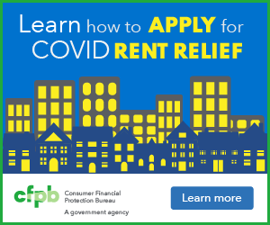
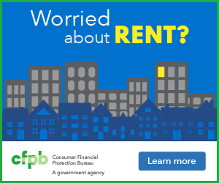
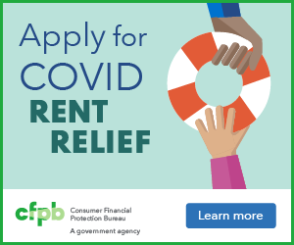
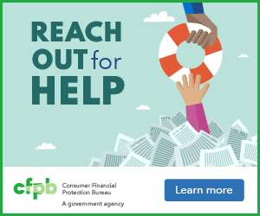
Graphics

Graphics
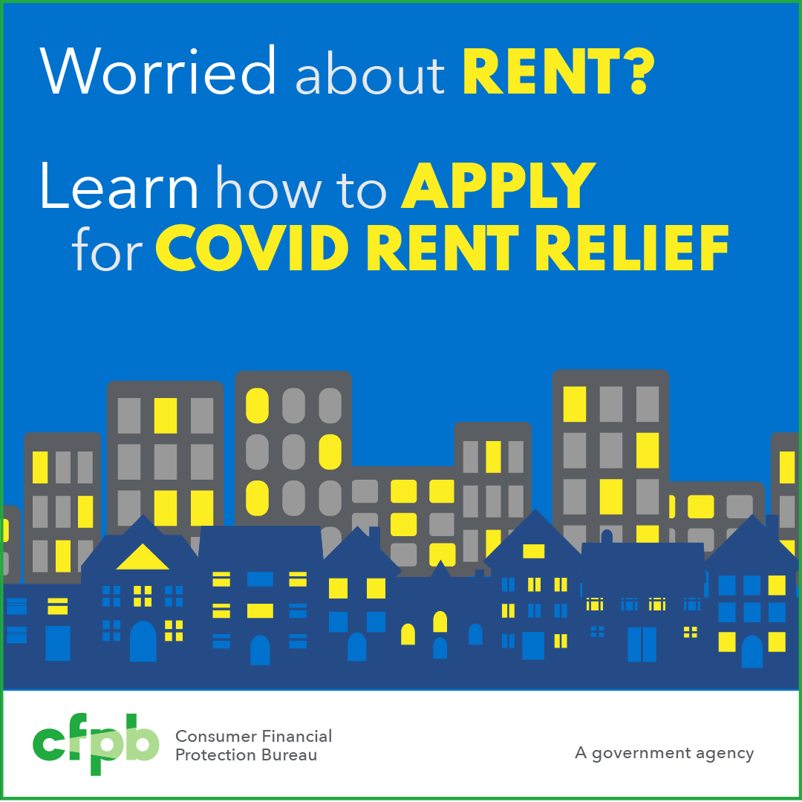
Graphics
